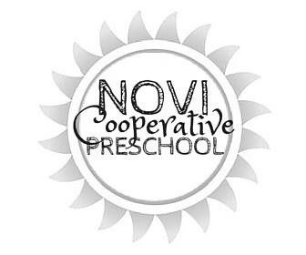

**A play-based kindergarten readiness program for 2 to 5 year olds**

**41671 Ten Mile Road Novi, MI 48375 ♥ (248) 349-3223 ♥** [**www.novipreschool.com**](http://www.novipreschool.com)

**3s Daily Schedule**

9:15-9:30 **Arrival/Free** Provides an opportunity to enter the classroom, greet others, and ease into the day. This period gives the children time to get excited for the day and to become comfortable saying goodbye.

9:15-9:30 **Circle Time** Encourages the development of communication and social skills, including listening, turn taking & body/space awareness. Children find a spot on the rug where they learn and discuss the activities for the day. Children may also learn about weather/season, count, and be assigned a job for the day, which encourages responsibility.

9:30-9:45 **Small Groups** Children explore, experiment, create, and problem solve with materials selected by the teacher. Teachers are able to facilitate and extend the learning of individual students.

9:45-10:35 **Discovery Time** Develops decision-making skills as children are free to explore any or all of the centers open for the day. Centers may include science, math, sensory play (playdough, water, sand, rice, etc.), housekeeping/dramatic play, climber, blocks, writing/literacy, manipulatives, and art. Children will strengthening fine motor skills, engaging in STEAM, and developing social skills such as playing cooperatively, problem solving, and conflict resolution.

10:34-10:45 **Clean Up** Teaches responsibility, teamwork, and caring for one’s belongings.

10:45-11:00 **Circle Time** Engages children in songs, finger plays, stories, and movement games/ This time helps develop self-confidence while reinforcing listening skills.

11:00-11:15 **Snack** Reinforces manners and nutrition concepts and further develops social skills.

11:20-11:40 **Outside Play** Increases social interaction, good sportsmanship, large motor skills and FUN! If weather does not permit – we will have music and movement inside.

11:40-11:45 **Dismissal** Strengthens memory and communication skills by reviewing the day. Children gather their belongings, sing our closing song & wait for dismissal.