Our Teachers…
3’s-CarrieCadicamo
“Mrs. C.” has a BA Degree in Child Psychology and Political Science from the University of Michigan. In addition, she has attended and presented various work-
shops and training in early childhood education. In
addition to her experience raising three girls, Carrie has
been an infant/toddler teacher, and nursery director at the First United Methodist Church in South Lyon, and a Parents’ Time Out program instructor. She is currently the Saturday Nursery and Preschool Coordinator at Oak Pointe Church. She has been a co-op parent with all three of her children, two of whom attended Novi Co-op. She has been working for Novi Co-op since 2008. Carrie offers a calm, loving, and warm environment in which children thrive.

4’s-Tracey Smith
Mrs. Smith is a graduate of Central Michigan University with a Bachelor of Applied Arts in Child Development/ Preschool. Tracey has been teaching at Novi Co-op since 1998. Prior to her years here, she has been employed as a kindergarten teacher, preschool teacher and child care director. In addition to teaching preschoolers at Novi Co-op, Tracey works as a Creative Programmer in the Children’s Ministry at Oak Pointe Church. Tracey has
been serving at the President of the Greater Detroit Cooperative Preschool Teachers Association since 2009. She brings years of experience as well as a sincere passion for helping children grow and develop in a nurturing learning environment.

The Novi Co-op Preschool curriculum is designed by our skilled teachers and prepares children for kindergarten by promoting social skills and life-long love of learning.

Novi Co-op Preschool
41671 Ten Mile Rd.
Novi, MI 48375

Located west of Meadowbrook Rd. in the Novi Methodist Church building.

For more information, visit
www.novipreschool.com
or call
(248)349-3223

Novi Co-operative Preschool is a non-denominational, non-profit organization licensed by Oakland County. We do not discriminate based on race, color, gender, religion or ethnic origin.

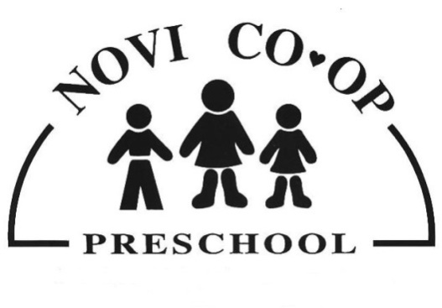

play-based
Kindergarten readiness program
for
ages
2-5

www.novipreschool.com
Our Philosophy

A play-based learning environment allows children to explore, create and develop new skills while having fun.
Novi Co-op Preschool activities are skillfully designed to help each child develop at his/her own pace in a nurturing atmosphere. Imaginative craft projects are offered daily to improve fine motor skills. Climbers, sensory tables, puppet theaters and many other learning tools are implemented in the classroom. Our outdoor playground offers children time for exercise and play in all types of weather.

Teacher-directed circle time gives children a chance to enjoy group stories, rhymes, poems and songs.

Our program fosters these developmental areas necessary for kindergarten readiness:
Fine and Gross Motor Skills
Pre-Math/Science
Social Skills
Creativity
Social Studies

Programs
Parent/Tot
Children must be age 2 by start of session
Wednesday: 9:30-10:45 or
Thursday: 9:30-10:45
$80 per 8-week session

3’s
Children must be age 3 by December 1st
Tuesday and Thursday:
9:15 to 11:45
$960/year

4’s
Children must be age 4 by December 1st
Monday,Wednesday,Friday: 9:00-12:00
$1440/year

4’s
Extended Wednesday
Monday and Friday:
9:00-12:00
Plus Wednesday: 9:00-2:30
$1725/year

Tuition rates are for the 2015-2016 school year.
Co-op?
What’s in it for me?

- Opportunity to participate in your child’s growth and development in the classroom.

- Receive support and education regarding parenting skills and strategies for dealing with typical preschool behavior.

- Join a community of other parents who value an active involvement in their child’s education.

- Reduce cost of tuition by sharing responsibilities of administrating the affairs of the preschool.

- Children receive the nurturing warmth of the presence of parents in the classroom.

www.novipreschool.com

